SCH4C December 2017
Answers to Review for Test #3: Stoichiometry
Name:
In order to do well on the unit test, you need to be able to:
- From the previous unit:
- Determine the number of significant digits in a measured number
- Use the symbols and units appropriately for mass, molar mass, moles, volume, concentration
- Calculate the molar mass of elements and compounds
- Calculate mass of a substance using the formula m = n x mm or concentration using c = n/v
- Calculate the number of moles of a substance using the formula n = m/mm and n = c x v
- Convert mL to L
- Mole to mole calculations: determine the number of moles of any substance in the balanced equation given the number of moles of one of the substances
- Mass to mass calculations: determine the mass of any substance in the balanced equation given the mass of one of the substances
- Concentration to mass calculations: determine the mass of any substance in the balanced equation given the concentration and volume of a solution in the equation
- Concentration to concentration calculations: determine the concentration of a solution in the balanced equation given the concentration of another solution in the equation
- Describe the titration process and perform titration calculations

The following sample questions will help you prepare for the test. The test will NOT be open book but you will be able to refer to this review assignment.
BASIC SKILLS from UNIT 2
- Determine the number of significant digits in the following.
- 2051 4 | - 0.236 3 | - 0.001 1

- How many significant digits should be recorded in the following calculations?
a) 15 x 25.0 2 | b) 150 /22.5 3 | c) 136/125.65 3

- Name the following pieces of equipment that we have used in this unit. What is it used for? How is it used?
Equipment | What is it used for? | How to use it/special instructions?
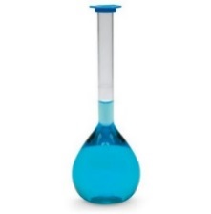 | See review for Test 2
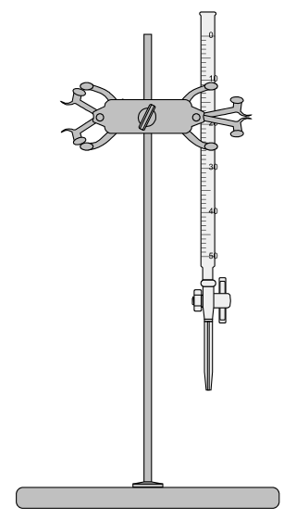 | Burette  Used in titration | Clamp it  Fill up including the part after the clamp to remove air  Controlled release of solution  Measure start and finish volumes
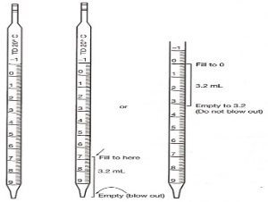 | See review for test 2

- Complete the following chart.
Quantity | Symbol | Units
Mass | m | g
Volume | v | mL or L
Molar mass | mm | g/mol
Concentration | C | mol/L
moles | n | mol

- Calculate the molar mass of CaBr₂.
mm = 40.08 + 2(79.90) = 199.88 g/mol
- Convert 25 mL to L.
Divide by 1000!!! 25/1000 = 0.025
- Convert 12.5 g of CaBr₂ to moles of CaBr_{2.}
n = m/mm = 12.5/199.88 = 0.0625 mol

- Convert 2.5 moles of CaBr₂ to mass of CaBr_{2.}
m = n x mm = 2.5 x 199.88 = 499.7 g or 500 g

NEW SKILLS from UNIT 3
- Perform the following mole to mole calculations.
Balanced equation | Given | Moles of A
1A + 1 B 1C  ? 2.5 | Number of moles of B is 2.5 | 2.5
2A + 1B 1 C  ? 0.40 | Number of moles of C is 0.40 | 0.40 x 2 = 0.80
2A + 2B 1 C  ? 5.0 | Number of moles of B is 5.0 | 5.0
1A + 2B C  ? 0.60 | Number of moles of B is 0.60 | 0.60/2 = 0.30

In this unit, you have determined mass or concentration of substance A in a balanced equation having being given either the concentration and volume or the mass of substance B in the equation. In each case the following 3 steps were followed:

- Convert concentration and volume or mass to moles of substance A
- Mole to mole calculation to determine moles of B
- Convert moles of B to either mass or concentration

Using the 3 steps listed above, answer the following questions. REMEMBER TO CHANGE ANY VOLUMES TO L!
- What mass of oxygen will be needed to react with 1.50 g of CH₄?

1CH₄ + 2O₂ CO₂ + 2H₂O
----- x 2 ---

mm of CH₄ = 16.042
mm of O₂ = 32.00

- n of CH₄ = m/mm = 1.50/16.042 = 0.094 mol

- n of O₂ = 0.094 x 2 = 0.188 mol

- m of O₂ = n x mm = 0.188 x 32.00 = 6.02 g

- What mass of AgCl will be produced when 25.0 mL (= 25.0/1000 = 0.0250 L) of a 0.200 mol/L solution of AgNO₃ react with aluminum chloride?
3AgNO_{3(aq)} + AlCl₃ Al(NO₃)_{3(aq)} + 3AgCl_{(s)}
--------------------------------- x 1 ------------------------------------>
mm of AgCl = 107.9 + 35.45 = 143.35 mol/L

- n of AgNO₃ = C x V = 0.200 x 0.0250 = 0.00500 mol

- n of AgCl = 0.00500 mol

- m of AgCl = n x mm = 0.00500 x 143.35 = 0.716 g

- What is the concentration of phosphoric acid, H₃PO_{4(aq)} when 18.5 mL (0.0185 L) of 0.200 mol/L NaOH is required to neutralize 10.0 mL ( 0.0100 L) of phosphoric acid?
1H₃PO_{4(aq)} + 3NaOH_{(aq)} Na₃PO_{4(aq)} + 3H₂O
---------------- ÷ 3 -----------
- n of NaOH = C X V = 0.200 x 0.0185 = 0.00370 mol

- n of H₃PO₄ = 0.00370/3 = 0.00123 mol

- C of H₃PO₄ = n/V = 0.00123/0.0100 = 0.123 mol/L

Percent yield: this is a good way to determine how well you have made a product. If the percent yield is low, somewhere in the experiment, some of the product was lost. This might be your error or an error in the design of the experiment.
- Calculate the percent yield in #11 if a student makes 0.622 g of AgCl.
% yield = experimental/theoretical x100 = 0.622/0.716 x 100 = 86.8%

- Lab-based question: Titration
Purpose: to determine the concentration of sulfuric acid, H₂SO_{4(aq)} using the titration method
Method:
- Using a pipette, measure 10.0 mL (0.010 L) of sulfuric acid and place it in an Erlenmeyer flask. Add 2 drops of phenolphthalein.
- Fill the burette with 0.25 mol/L NaOH.
- Titrate the sulfuric acid with the sodium hydroxide solution.

Results:
 | Trial 1 | Trial 2 | Trial 3
Final reading in burette (mL) | 12.5 | 26.0 | 38.2
Starting reading in burette (mL) | 0 | 12.5 | 26.0
Volume of sodium hydroxide added | 12.5 | 13.5 | 12.2

- Complete the chart above.
- Calculate the average volume of NaOH added.
Average volume of NaOH required = (12.5 + 13.5 + 12.2) / 3 = 12.7 mL or 0.0127 L

- Calculate the number of moles of NaOH needed to neutralize the acid.
n of NaOH = C x V = 0.25 x 0.0127 = 0.00318 mol

- Using the balanced equation that follows, determine the number of moles of sulfuric acid that were neutralized.
1H₂SO_{4(aq)} + 2NaOH_{(aq)} Na₂SO_{4(aq)} + 2H₂O
-------------- ÷ 2 -----------

n of H₂SO₄ = 0.00318/2 = 0.00159 mol

- Determine the concentration of the sulfuric acid.
C = n/V = 0.00159/0.0100 = 0.159 mol/L

